https://docs.oracle.com/en-us/iaas/Content/data-science/using/policies.htm

Aggregate Resource Type
data-science-family
Individual Resource Types
data-science-work-requests
data-science-projects
data-science-notebook-sessions
data-science-jobs
data-science-job-runs
data-science-pipelines
data-science-pipeline-runs
data-science-private-endpoint
data-science-schedules
data-science-models
data-science-model-groups
data-science-model-group-version-histories
data-science-modelversionsets
data-science-model-deployments

allow <subject> to <verb> <resource_type> in <location> where <conditions>.
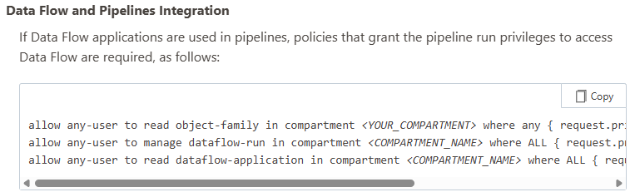
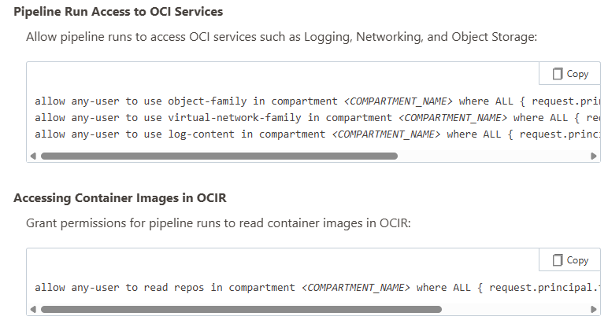
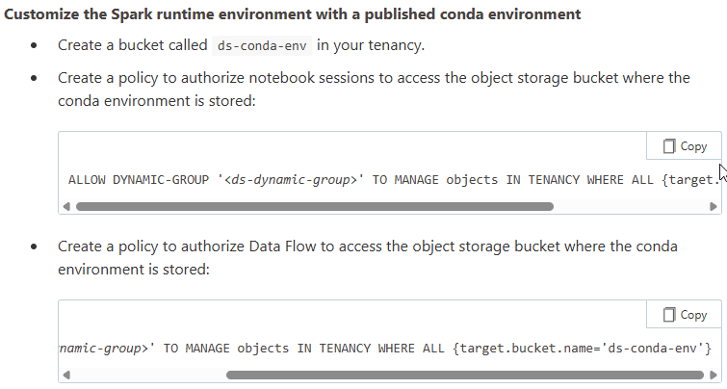
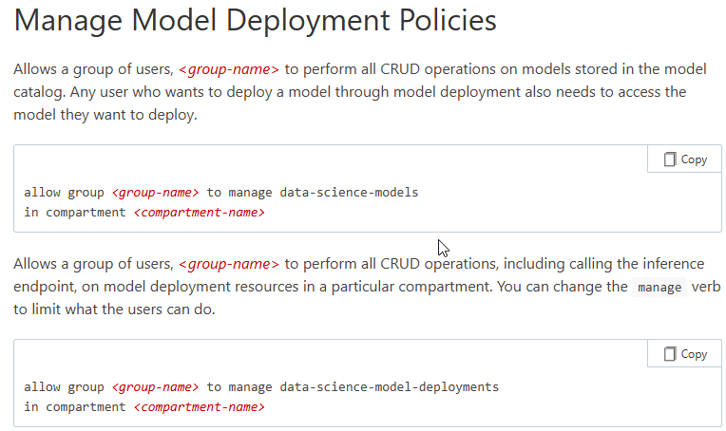
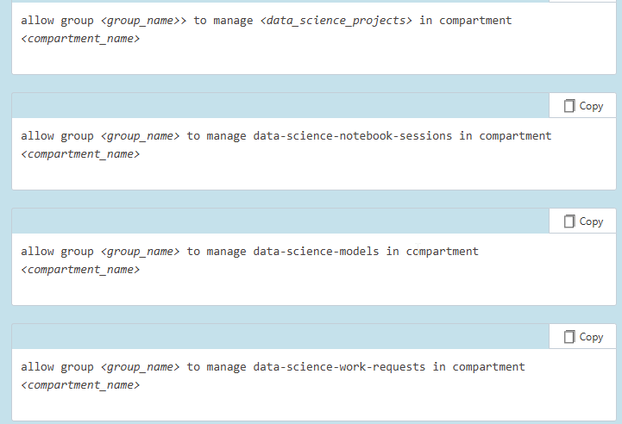
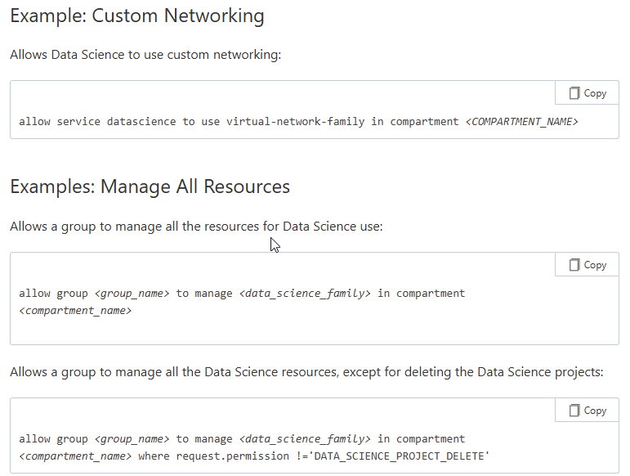
inspect to read to use to manage.

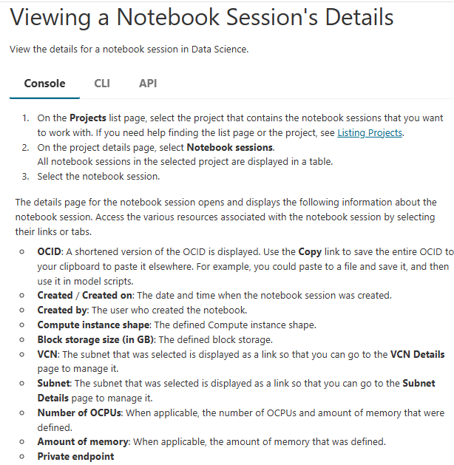
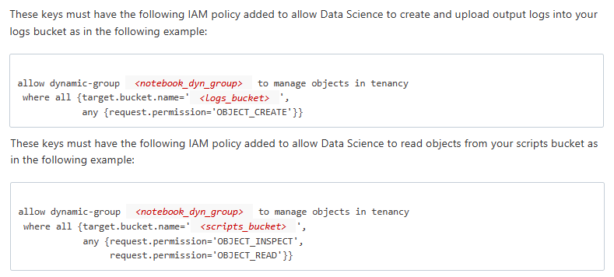
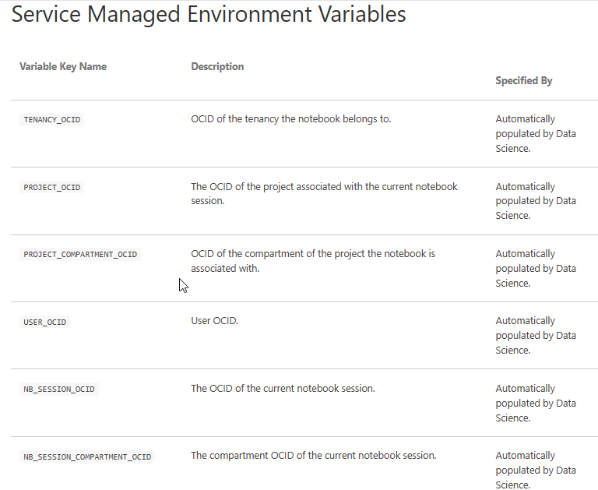
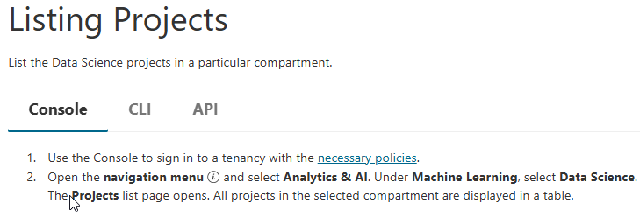
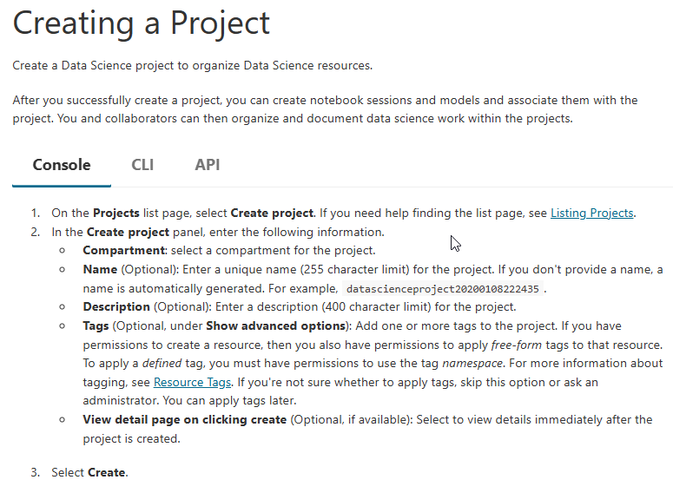
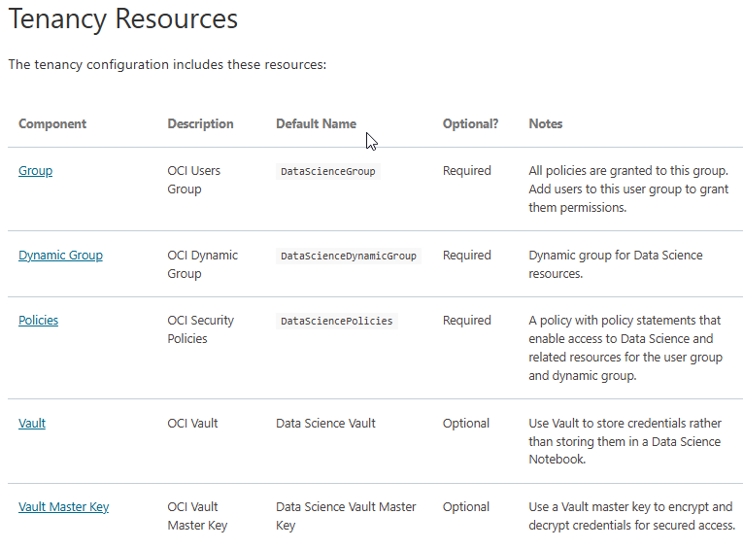
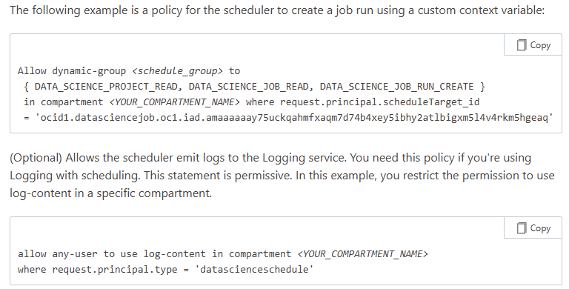
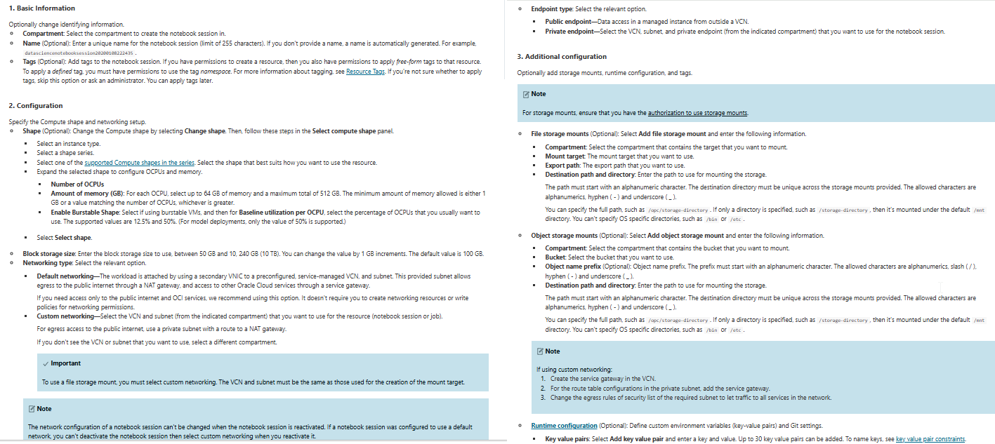
About Deactivating Notebook Sessions🔗
Before you deactivate a notebook session, save your work to its attached block volume to retain the data. Any data on the boot volume of the notebook session is deleted after you deactivate it.
When you deactivate a notebook session, the underlying Compute instance stops and, the attached block volume is detached and preserved. The block volume drive is mounted in /home/datascience so any data, notebooks, and conda environments that you save are stored there. The work you save in the block volume drive is retained after a notebook session is deactivated. When a notebook session is reactivated, you can access the work that you saved in the block volume.
While activating a notebook session, you can change the following:

- Compute shape
- Block volume size
- VCN
- Subnet
- Storage mounts
- Runtime configuration's custom environment variables and Git repository URLs to clone

Note
- The network configuration of a notebook session can't be changed when the notebook session is reactivated. If a notebook session was configured to use a default network, you can't deactivate the notebook session then select custom networking when you reactivate it.
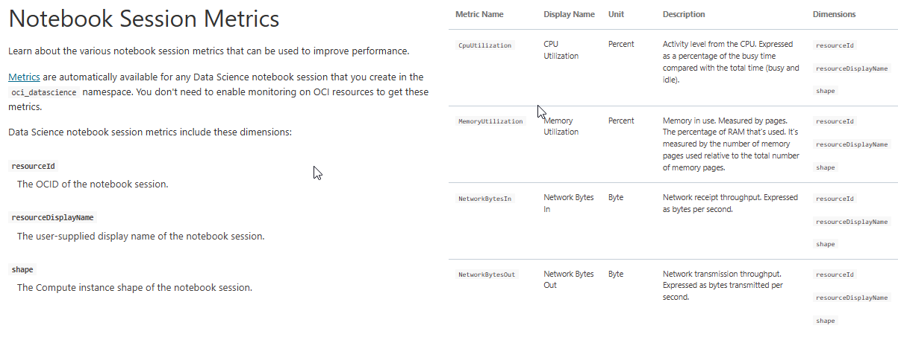
- If you change the block volume size, then you must specify a larger value than the current block volume size.

Persisting Data and Files on a Notebook Session Block Volume
Files and data on the local disk of a notebook session Compute aren't persisted when the notebook session is deactivated or fails.
To persist files and data, you must save them to OCI Block Volumes. A Block Volume is mounted in /home/datascience. You can access it from the JupyterLab file tree.
When you deactivate a notebook session, the files stored on the Block Volume are mounted back in /home/datascience after you activate a notebook session. To back up data, push code changes to a remote Git repository, and then save the data to OCI Object Storage.

Allocating Notebook Session Swap Space
Learn how we recommend that you allocate block volume space for notebook sessions.
Swap space is allocated on disk and is used as memory when the RAM is full. Space on the attached Block Volume is allocated for swap space for a notebook session. The swap space you allocate to the notebook is the minimum of the memory-configuration of the Compute shape you selected or 25% of the total Block Volume storage.
For example, if the memory of the Compute shape is 16 GB and the Block Volume is 100 GB, then the swap space allocated to the notebook is 16 GB. This is because 16 GB is smaller than 25 GB, which is 25% of the total Block Volume.

By default, you're automatically logged out of a notebook session after an hour of inactivity.
This behavior can be changed in each notebook to extend the notebook session time up to 24 hours, depending on the tenancy.
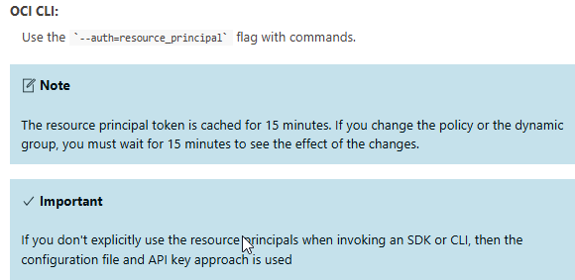
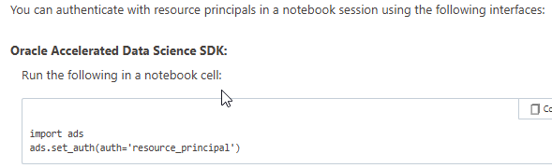
To increase the notebook time-out to the maximum limit for a tenancy, select Extend next to Session remaining.

(Default) Authenticating Using OCI Configuration File and API Keys
You can operate as your own IAM user by setting up an OCI configuration file and API keys to access OCI resources. This is the default authentication approach
To authenticate using the configuration file and API key approach, you must upload an OCI configuration file into the notebook session's /home/datascience/.oci/ directory. For the relevant profile defined in the OCI configuration file, you also need to upload or create the required .pem files.

With ADS you can:
- Read datasets from Object Storage, Oracle Database (ATP, ADW, and On premises), AWS S3, and other sources into Pandas data frames.
- Tune models using hyperparameter optimization with the ADSTuner module.
- Generate detailed evaluation reports of model candidates with the ADSEvaluator module.
- Save machine learning models to the Data Science model catalog.
- Deploy models as HTTP requests with model deployment.
- Start distributed ETL, data processing, and model training jobs in Spark using Data Flow.
- connect to the BDS from the notebook session, the cluster created must have Kerberos enabled.
Use Kerberos enabled clusters to connect to Big Data from a notebook session.
- Use feature types to characterize data, create meaning summary statistics, and plot. Use the warning and validation system to test the quality of data.
- Train machine learning models using Data Science Jobs.
- Manage the life cycle of conda environments using the ads conda CLI.

Although the conda CLI is available in a notebook session, we recommend that you use odsc conda to browse, install, clone, publish, and delete conda environments. preinstalled in notebook sessions and is available in a terminal window tab. The odsc conda CLI installs the necessary dependencies in a conda to make it available as a kernel in JupyterLab and creates the required manifest file that's necessary for each conda environment.
- <Token> returns items that are a fuzzy match of <Token>
- <Example> <Token> returns items that are a fuzzy match of <Example> and <Token>
- <Example> | <Token> returns items that are a fuzzy match of <Example> or <Token>
- ="<Example> <Token>"returns items that are an exact match of <Example> <Token>
- <Token> returns items that include <Token>
- !<Token> returns items that don't include <Token>
- ^<Token> returns items that start with <Token>
- !^<Token> returns items that don't start with <Token>
- <Token>$ returns items that end with <Token>
- !<Token>$ returns items that don't end with <Token>

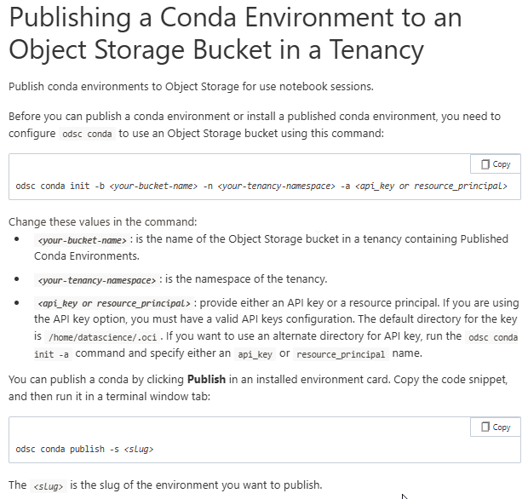
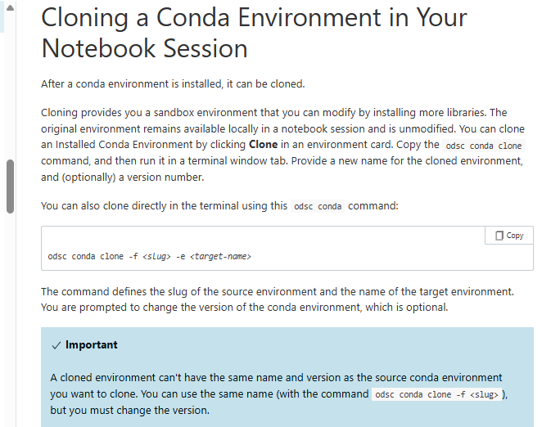
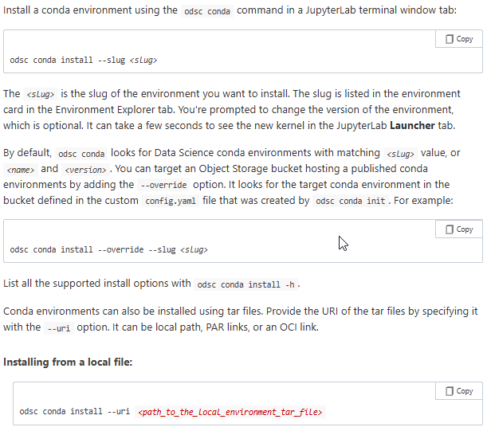
Important
Before you can publish environments, you need to specify the namespace and the bucket that you want to use to store the conda environments. You do this with the odsc conda init command. Make sure that you use either resource principals, or that you have setup the proper configuration and key files to let odsc conda read and write to the Object Storage bucket.

Model Catalog
The model catalog is a centralized and managed repository of model artifacts. Models stored in the model catalog can be shared across members of a team and they can be loaded back into a notebook session. For example, models in the model catalog can also be deployed as HTTP endpoints using a model deployment.
A model entry in the model catalog has two components:
- A model artifact is a zip archive that includes the saved model object. A Python script providing instructions about how to use the model for inference purposes (score.py), and a file documenting the runtime environment of the model (runtime.yaml). You can obtain artifact, score.py, and runtime.yaml examples from Github.
Model artifacts stored in the model catalog are immutable by design. Any changes you want to apply to a model requires that a new model is created. Immutability prevents unwanted changes, and ensures that any model in production can be tracked down to the exact artifact behind the model predictions.

Important :
Artifacts have a maximum size limit of 100 MB when saved from the Console. The size limit has been removed from ADS, the OCI SDKs, and CLI. Large models have artifacts limitations of up to 400 GB.

Provenance
Model provenance is documentation that helps you improve the model reproducibility and auditability. You can document the resource that the model was trained in (either a notebook session or job run), and the Git reference to the training source code. These parameters are automatically extracted when you save a model with the ADS SDK.
When you're working inside a Git repository, ADS can obtain Git information and populate the model provenance metadata fields automatically for you.
Model Introspection Tests
Introspection in the context of machine learning models is a series of tests and checks run on a model artifact to test all aspects of the operational health of the model. These tests target the score.py and runtime.yaml with the goal to capture some common errors and issues of the model artifact. Introspection tests results are part of the pre-defined model metadata. If you save your model using the Console, you can store the test results in JSON format in the Artifact Test Results field when you select Document model taxonomy. If you decide to save the model using the OCI Python SDK, use the ArtifactTestResults metadata key.
Preparing a Model Artifact
After a model is trained, you must create a model artifact to save with the model in a model catalog.
This creates centralized storage of model artifacts to track model metadata.
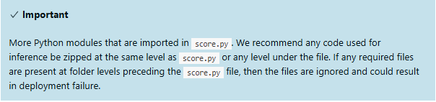
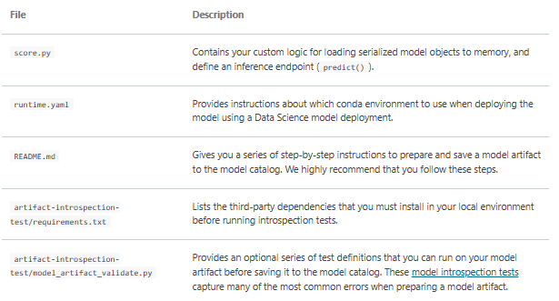
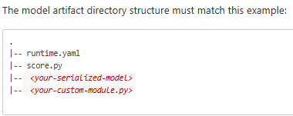
A model artifact is a zip archive of the files necessary to deploy the model as a model deployment or load it back in a notebook session.

The score.py File🔗
This file contains the function definitions that are necessary to load a model to memory and make predictions.
The two functions are called, load_model() and predict(). The function parameters are not customizable. For example, you can define data transformations in predict() before calling the inference method of the estimator object. You can load more than one estimator object to memory and perform an ensemble evaluation. The predict() function is behind the /predict endpoint of a model deployment. Ensure that the data type of the data parameter in predict() matches the payload format you expect with model deployment.
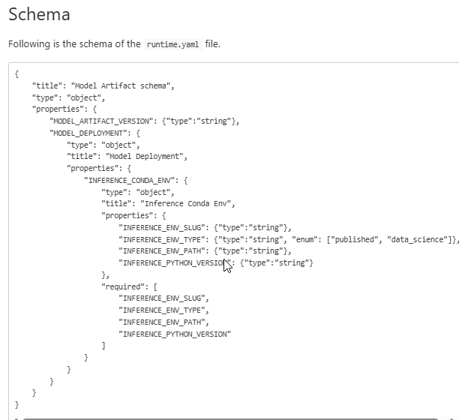
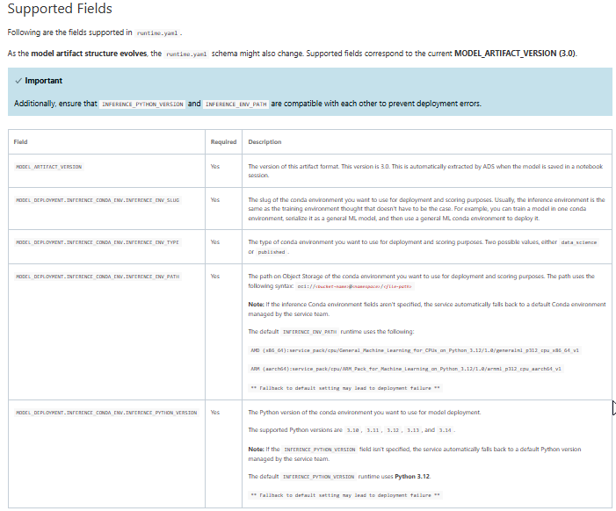
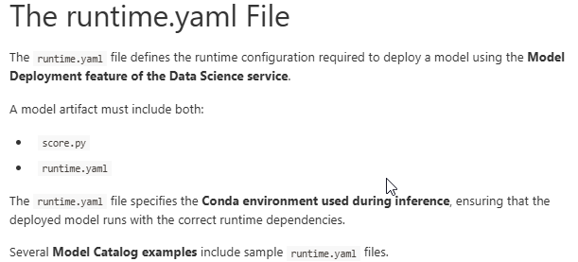
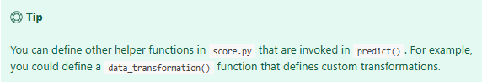
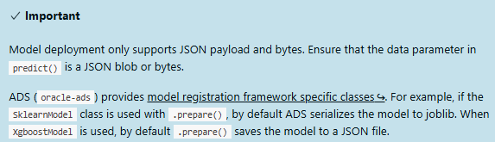
The score.py template uses the load_model() to return the model estimator object. The predict () function takes in data and the model object returned by the load_model(). Both functions are customizable and require definitions. The body of predict() can include data transformations and other data manipulation tasks before a model prediction is made. Any custom Python modules can be imported in score.py if they're available in the artifact file or as part of the conda environment used for inference purposes such as the template.
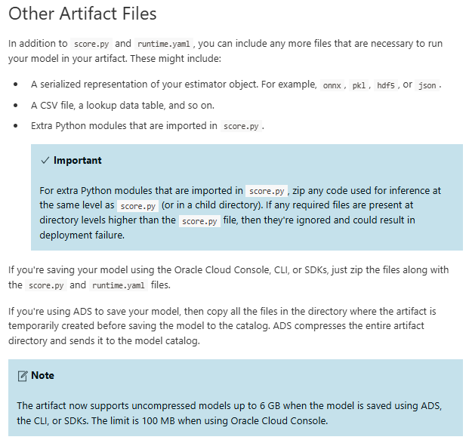
Writing a score.py File
- Always ensure that the score.py and runtime.yaml files are in the top-level directory of a model artifact.
Any other files that need to be part of a artifact must be at the same level as those two files or in directories under them:
|-- runtime.yaml
|-- score.py
|-- <your-serialized-models>
- Model deployment uses the score.py functions to load a model into memory and to make predictions.
- The function definitions, load_model() and predict(), aren't editable. Only the body of these functions is customizable.
- The allowed path to write data to disk when using model deployment service is /home/datascience.
- You can access Object Storage using resource principals when the OCI identity permissions are defined correctly to enable it.

Packaging Custom Modules
Any custom module on which score.py or the serialized model depends on should be written as separate Python scripts in the same top level directory as score.py or under. For example, model.joblib depends on a custom DataFrameLabelEncoder class, which is defined in the dataframelabelencoder.py script as in this example:
Changing load_model() and predict() signatures
The predict(data, model=load_model()) function expects the payload data and a model object and is returned by load_model() by default. Your use case might require that an extra parameter is passed to predict(). An example is a scaler or a lookup table. You can add parameters to those function if the parameter you add has a default value assigned.
In the following example, the predictions rely on a PCA model and a scaler object. It shows you how predict() can take an extra parameter called scaler. By default, the load_scaler() function returns a value to the scaler parameter. We recommend that you follow that pattern. If predict() or load_model() require extra parameters, they must be set to default values returned by functions that are defined in score.py. This example adds parameters to predict():
Testing a Model Artifact Before Saving
Before saving a model to the catalog, we recommend that you test the artifact thoroughly. This code snippet to tests a model artifact before saving it to the catalog:
- Changes the Python path by inserting the path to the model artifact.
- Loads the model into memory using load_model().
- Lastly, calls predict().

Before you run the code snippet, create a new notebook file in a notebook session, change the kernel, and then select the same conda environment that you want to use for model deployment (inference conda environment). Copy and paste the code snippet and run the code.
The predictions_test method contains the predictions made by the model on the sample data JSON string payload. Compare predictions_test against a known model outcome for a particular dataset. For example, data could be a sample of the training dataset.
Image Predictions Example
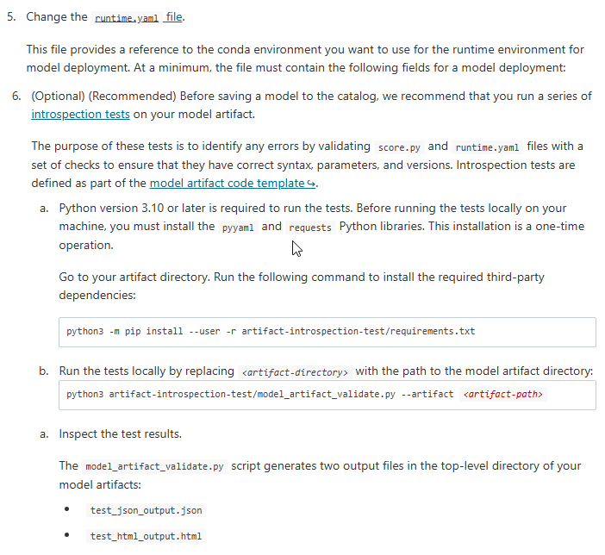
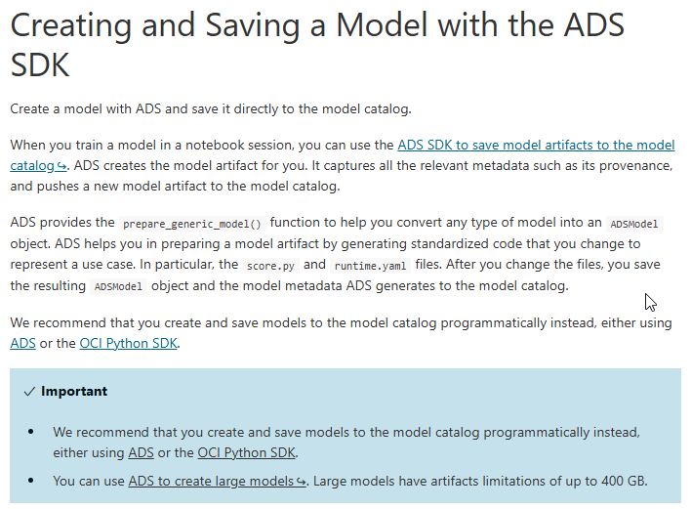
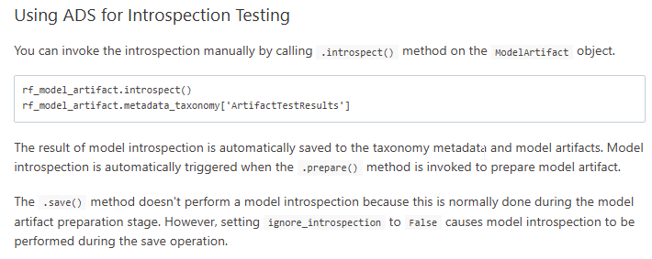
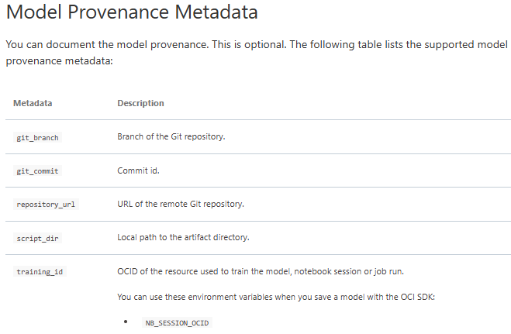
The score.py predict() method handles the processing from the received request as in this example s core.py file:
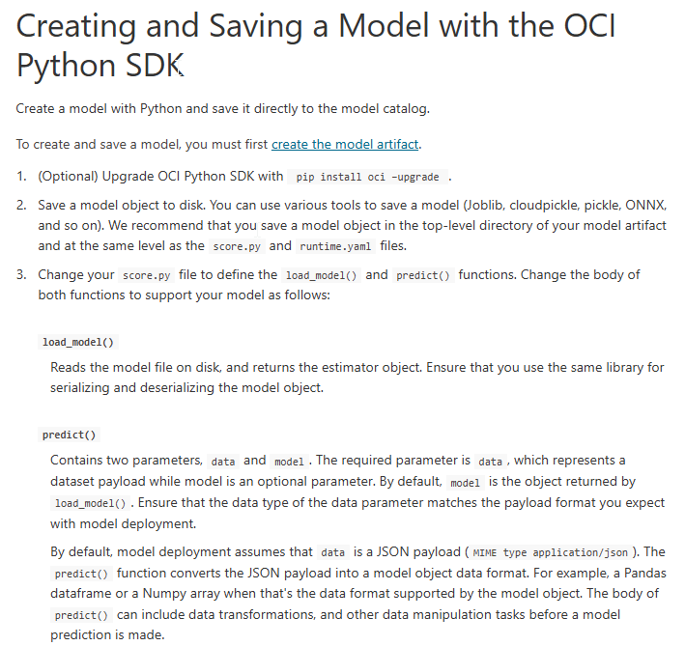
Creating and Saving a Model with the Console: Link
Exporting a Large Model Artifact : https://docs.oracle.com/en-us/iaas/Content/data-science/using/large-model-artifact-export.htm
Deactivating and Activating a Model
Activate a deactivated Data Science model or deactivate an active one.
Deactivating a model updates its state to inactive. Inactive models can't be used in a model deployment. Inactive models aren't deleted and can later be reactivated.
Model Deployments
Model deployments are a managed resource in the OCI Data Science service to use to deploy machine learning models as HTTP endpoints in OCI. Deploying machine learning models as web applications (HTTP API endpoints) serving predictions in real time is the most common way that models are productionized. HTTP endpoints are flexible and can serve requests for model predictions.
Model deployments can now enable service-managed public internet access. With this option, instances can access public repositories and other Oracle Cloud services through an OCI-managed NAT gateway.
You can continue to use service-managed networking without internet access or specify a customer-managed subnet if those options better meet your governance requirements.
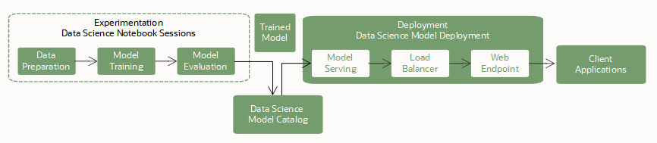
Data Science supports container signing as a security control for model deployments. The service validates uploaded signatures against the specified OCI Vault keys before it activates the deployment. For more information about configuring the required access, see the prerequisites for Overview of Vault and IAM policies.

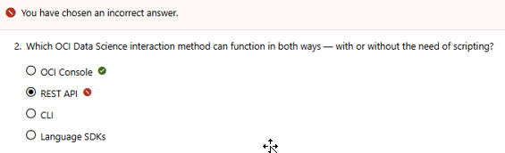
Q/A:
The correct answer is the OCI Console.
Why the OCI Console is correct:
- No-scripting interaction: The OCI Console provides a web-based, user-friendly graphical interface (GUI). Users can create, manage, and configure Data Science resources (like notebook sessions or models) purely by clicking through menus without writing any code.
- Scripting interaction: At the same time, the console integrates tools like the OCI Cloud Shell and provides shortcuts to view or generate equivalent CLI commands directly within the GUI wizard, making it useful for both manual tasks and scripting/automation.

Why the other options are incorrect:
- REST API: Interacting with the REST API inherently requires scripting or coding to structure HTTP requests (GET, POST, etc.) and parse JSON payloads.
- CLI (Command Line Interface): The CLI is a text-based terminal tool designed for executing commands and creating automation scripts. It does not provide a no-scripting graphical interface.
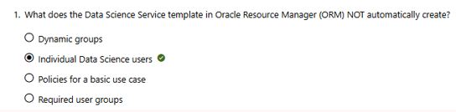
- Language SDKs: Software Development Kits (like the OCI Python SDK) are built entirely for developers and strictly require writing code in a programming language to function.

The correct answer is Individual Data Science users.
Why individual users are NOT automatically created:
The Data Science Service template in Oracle Resource Manager (ORM) is designed to automate the underlying governance structure and security foundations, not identity provision. Human users are distinct entities in OCI Identity and Access Management (IAM) that must be created or managed independently by your organization's cloud administrator.
Once created, you manually assign those individuals to the permissions groups the template built.

What the template DOES automatically create:
- Dynamic groups: It defines a dynamic group containing all the data science resources (such as notebook sessions) so they can authenticate via resource principals.
- Required user groups: It automatically sets up placeholder user groups (e.g., a group specifically for your Data Scientists).
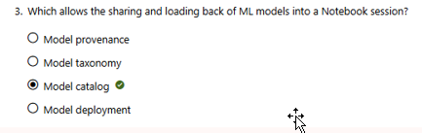
- Policies for a basic use case: It writes the necessary OCI IAM policy statements allowing the user groups and dynamic groups to manage projects, notebooks, and models safely.

The correct answer is the Model catalog.
Why Model catalog is correct:
- Central repository: In OCI Data Science, the model catalog is a centralized, managed library where team members save, version, and share machine learning models.
- Loading back: It allows you to download and load a saved model artifact directly back into any active Notebook session to continue working or running evaluations.

Why the other options are incorrect:
- Model provenance: This simply tracks the background metadata of the model, such as the exact training code, Git commit hash, and environment variables used to create it.
- Model taxonomy: This refers to the schema or classification data describing the model, like the target machine learning framework (e.g., scikit-learn, TensorFlow) and version.
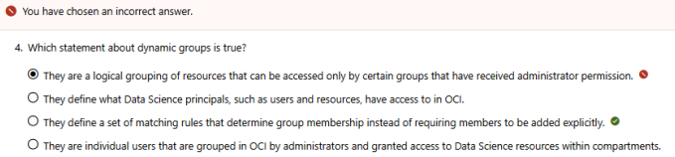
- Model deployment: This is the process of hosting a model as a real-time HTTP endpoint so applications can send data and receive predictions.

The correct answer is: They define a set of matching rules that determine group membership instead of requiring members to be added explicitly.
Why this option is correct:
- Rule-based membership: In OCI Identity and Access Management (IAM), dynamic groups allow you to group compute instances or OCI resources (like Data Science notebook sessions) automatically based on specific matching rules (e.g., all instances in a particular compartment). You do not manually add or remove individual resources from the group.

Why the other options are incorrect:
- Option 1 (Your selection): This incorrectly defines how dynamic groups operate. Dynamic groups contain compute instances or service resources, not user groups, and their access is determined by OCI policies, not administrator-only access limits.
- Option 2: Dynamic groups do not define what resources have access to; rather, policies define what a dynamic group is allowed to do.
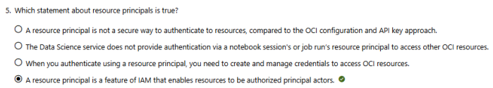
- Option 4: Dynamic groups contain OCI cloud resources (like virtual machines), whereas traditional user groups are used to organize individual human users.
The correct answer is: A resource principal is a feature of IAM that enables resources to be authorized principal actors.
Why this option is correct:
- Resource authorization: In Oracle Cloud Infrastructure (OCI), a resource principal allows a resource (like a Data Science notebook session or a job run) to act as an authorized actor. This means the resource itself can securely authenticate and call other OCI services (such as Object Storage or the Model Catalog) directly based on IAM policies.

Why the other options are incorrect:
- Option 1: Resource principals are actually more secure than using API keys or OCI config files, as they eliminate the risk of hardcoding credentials or exposing configuration files within your notebook environment.
- Option 2: The Data Science service explicitly provides built-in support for resource principals in both notebook sessions and job runs to easily interact with other cloud resources.
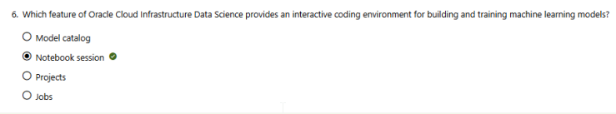
- Option 3: The main benefit of resource principals is that you do not need to manually create, rotate, or manage cryptographic credentials; OCI handles authentication automatically behind the scenes.
The correct answer is Notebook session.
Why Notebook session is correct:
- Interactive development: A notebook session in OCI Data Science provides data scientists with a managed, web-based JupyterLab environment. It allows you to interactively write code, visualize data, and run machine learning experiments in real time.

Why the other options are incorrect:
- Model catalog: This serves as a centralized, secure storage repository for saving, versioning, and sharing completed machine learning model artifacts rather than writing code.
- Projects: Projects are purely logical organizational containers used to group related resources like notebooks, jobs, and models together for collaboration and tracking.
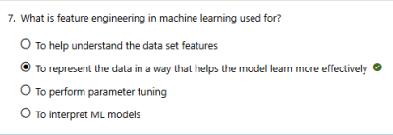
- Jobs: Jobs are designed for executing automated, non-interactive batch tasks or long-running scripts (like scheduled model retraining) without a graphical user interface.
The correct answer is: To represent the data in a way that helps the model learn more effectively.
Why this option is correct:
- Data transformation: Feature engineering is the process of using domain knowledge to select, transform, combine, or create new variables (features) from raw data.
- Enhancing learning: By structuring raw data into more meaningful representations (e.g., scaling numerical features, encoding categories, or creating interaction terms), you make it easier for machine learning algorithms to uncover underlying patterns and improve predictive accuracy.

Why the other options are incorrect:
- To help understand the data set features: This describes exploratory data analysis (EDA), which focuses on examining and visualizing data to summarize its main characteristics before modifying it.
- To perform parameter tuning: This is part of the model optimization phase (hyperparameter tuning), where you adjust algorithmic settings (like learning rates or tree depths) to boost performance.
- To interpret ML models: This refers to model explainability or interpretability methods (like SHAP or LIME values) used to understand why a model makes specific predictions after it has been trained.
- Key Methods: SHAP vs. LIME
Feature | SHAP (Shapley Additive exPlanations) | LIME (Local Interpretable Model-agnostic Explanations)
Core Concept | Uses cooperative game theory to assign an attribution value to each feature. | Approximates a complex black-box model with a simpler, local surrogate model (like linear regression).
Scope | Provides both local (single prediction) and global (overall dataset) explanations. | Strictly provides local explanations.
Data Types | Excellent for tabular data, text, and images. | Highly flexible; works on text, tabular, and image data.
Pros | Strong mathematical foundation; fair and consistent feature attribution. | Easy to use and fast; gives intuitive "contrastive" explanations.
Cons | Can be computationally expensive for large datasets or complex models. | Explanations can be unstable or vary based on the perturbation sample size.

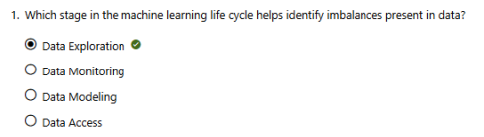
The correct answer is Data Exploration.
Why Data Exploration is correct:
- Identifying patterns and distributions: Data Exploration (or Exploratory Data Analysis - EDA) is the stage where you calculate summary statistics and visualize your dataset distributions.
- Spotting anomalies: During this phase, plotting class frequencies or target distributions immediately reveals if certain categories are heavily over-represented or under-represented (class imbalance), allowing you to plan corrective strategies before training.

Why the other options are incorrect:
- Data Monitoring: This happens after a model is deployed to production. It tracks live incoming data over time to check for data drift or performance degradation, rather than uncovering initial baseline dataset imbalances.
- Data Modeling: This is the phase where you select machine learning algorithms and train them on your prepared data. While an imbalanced dataset will negatively affect modeling, the imbalance itself should be identified and handled prior to this step.
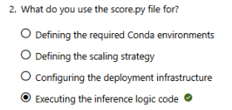
- Data Access: This is the initial step of authenticating, connecting to data sources (like databases or object storage), and retrieving raw data, without performing any analytical checking or computation on its contents.
The correct answer is Executing the inference logic code.
Why executing the inference logic code is correct:
- Inference logic: In OCI Data Science model deployment, the score.py file is the primary script that specifies how a model processes live incoming data. It contains two required functions: load_model() (which loads the saved model artifact into memory) and predict() (which takes payload data, runs it through the model to get a prediction, and returns the result).

Why the other options are incorrect:
- Defining the required Conda environments: This is handled by the runtime.yaml file in the model artifact, which specifies the exact conda environment name and slug required to run the model.
- Defining the scaling strategy / Configuring deployment infrastructure: These are configured using infrastructure parameters (like instance shape, count, and autoscaling policy) via the OCI Console, CLI, or SDK during the model deployment setup phase, not inside a script file.

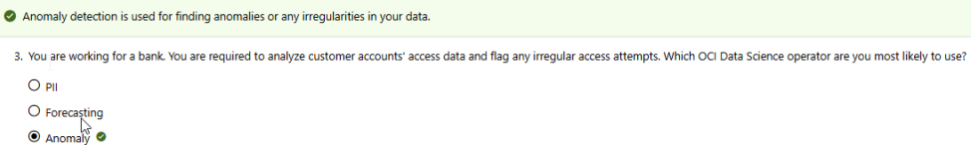
The correct answer is Anomaly.
Why Anomaly Detection is correct:
- Flagging irregular patterns: In machine learning, "irregular access attempts" or suspicious activities are outliers that deviate significantly from standard user behavior. The OCI Data Science Anomaly Detection operator is purpose-built to automatically identify these unusual data points or patterns in time-series data without requiring a data scientist to manually build a complex model from scratch.

Why the other options are incorrect:
- PII (Personally Identifiable Information): This operator is used to detect, mask, or redact sensitive personal data (like Social Security numbers, names, or addresses) for compliance and privacy reasons. It does not analyze behavioral irregularities or access attempts.
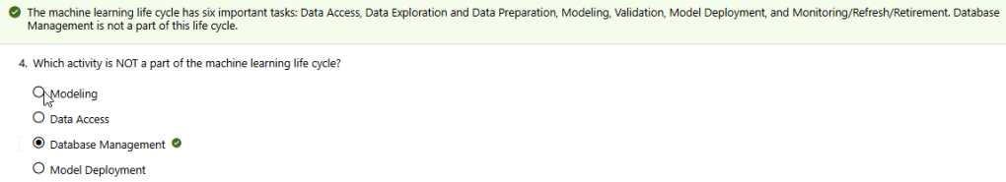
- Forecasting: This operator is designed to predict future numerical trends or data points based on historical data (such as predicting future sales volumes, stock levels, or server load metrics), rather than identifying current malicious or outlier behavior.
The correct answer is Database Management.
Why Database Management is correct:
- Outside the ML scope: While machine learning relies heavily on data stored in databases, Database Management (tasks like indexing tables, tuning database servers, and handling relational backups) is an operational database administrator (DBA) function rather than an inherent stage of the core machine learning workflow.

Why the other options are incorrect:
As highlighted in the green confirmation banner, the machine learning life cycle explicitly includes these core phases:
- Data Access: Retrieving raw source datasets from databases or cloud storage.
- Modeling: Selecting mathematical algorithms and training them on the prepared data.
- Model Deployment: Promoting a completed, validated model into production environments so it can serve live traffic and make real-time predictions.

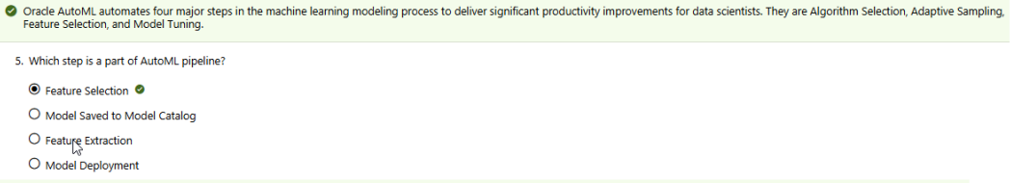
The correct answer is Feature Selection.
Why Feature Selection is correct:
- Core AutoML Step: Oracle AutoML automatically evaluates your dataset and isolates the most predictive columns while discarding irrelevant or noisy data. As explicitly noted in the top banner, the four mathematical pipeline phases automated by Oracle AutoML are Algorithm Selection, Adaptive Sampling, Feature Selection, and Model Tuning.

Why the other options are incorrect:
- Feature Extraction: While related to data prep, Feature Extraction creates entirely new variables from raw data (like extracting text features or transforming pixel matrices). AutoML operates on the existing feature space using Feature Selection instead.
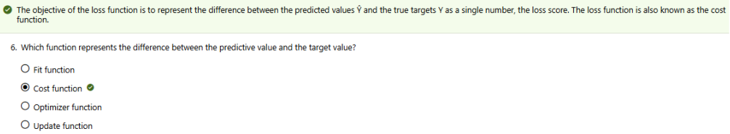
- Model Saved to Model Catalog & Model Deployment: These are MLOps infrastructure steps that happen after the AutoML optimization pipeline has finished generating and tuning the final model.

The correct answer is Cost function.
Why Cost function is correct:
- Quantifying Error: A loss function (interchangeably called a cost function) measures how wrong a machine learning model's predictions are compared to the actual real-world targets. It mathematical reduces all individual prediction errors into a single scalar number that the model tries to minimize during training.

Why the other options are incorrect:
- Fit function: This is an operational command or method used in machine learning libraries (like calling .fit() in scikit-learn) to initiate the overall training process on a dataset.
- Optimizer function: This is the algorithm (such as Gradient Descent or Adam) that uses the score from the cost function to calculate how to adjust the model's weights to minimize errors.
- Update function: This refers to the specific mathematical step within the optimizer that applies the newly calculated adjustments to update the model parameters.
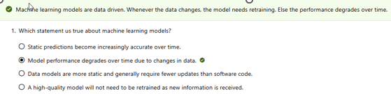
1. Machine Learning Models
- Correct Answer: Model performance degrades over time due to changes in data.
- Explanation: Real-world environments are highly dynamic, leading to data drift or concept drift. Because the underlying behavioral patterns change, static models steadily lose accuracy over time and require ongoing retraining.
- Incorrect Options: Models do not naturally gain accuracy without code/parameter adjustments. They are not more static than traditional source code and inherently depend on a constant stream of new training inputs to stay functional.
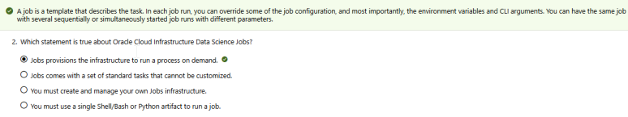
2. OCI Data Science Jobs
- Correct Answer: Jobs provisions the infrastructure to run a process on demand.
Why this option is correct:
- Managed computing: OCI Data Science Jobs are fully managed. The service automatically spins up the required compute infrastructure when a job run starts. It shuts down the resources once the task is complete.

Why the other options are incorrect:
- Option 2: Jobs are highly customizable. You can pass runtime CLI arguments and modify environment variables.
- Option 3: OCI completely manages the underlying hardware and infrastructure provisioning for you.
- Option 4: You can bundle entire directories or zip archives containing complex, multi-file code dependencies, not just a single script.
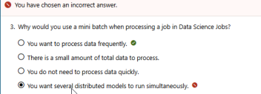
3. Mini-Batch Processing
- Correct Answer: You want to process data frequently.
Why this option is correct:
- Frequent processing: Mini-batch processing breaks down incoming data into small, manageable subsets. This enables scheduled or event-driven jobs to run frequently (e.g., hourly), preventing massive data backlogs and avoiding continuous infrastructure uptime costs.

Why the other options are incorrect:
- Option 2: If you only have a small total amount of data, you would typically run a single, quick standard batch job rather than needing a mini-batch architecture.
- Option 3: Mini-batching is specifically used to keep processing windows short and efficient, allowing data pipelines to remain fast and near-current.
- Option 4 (Your selection): Running multiple distributed models concurrently refers to parallel or distributed cluster computing, which is separate from chunking data via mini-batches.
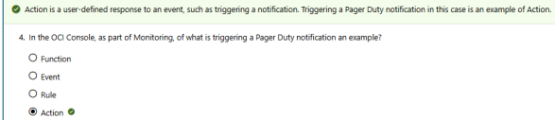

4. PagerDuty Notification Monitoring
- Correct Answer: Action
- Explanation: Within Oracle Cloud Infrastructure, an infrastructure event triggers a defined alarm or monitoring rule condition. The downstream consequence that handles delivering an external payload (like dispatching an alert to a PagerDuty webhook or an email address) is formally classified as an Action.
- Incorrect Options: Functions represent code execution services, Rules are the logical filters checking specific telemetry conditions, and Events are the raw lifecycle metrics generated by cloud resources.
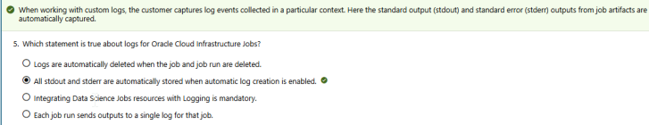
5. Data Science Jobs Logging
- Correct Answer: All stdout and stderr are automatically stored when automatic log creation is enabled.
Why this option is correct:
- Automated capturing: As confirmed by the top green banner, when you enable logging for OCI Data Science Jobs, the system automatically captures and redirects all standard output (stdout) and standard error (stderr) streams directly from your running script containers into OCI Logging.

Why the other options are incorrect:
- Option 1: Logs are independent, persistent resources stored within the OCI Logging service. They remain searchable for your configured retention period even if the parent job or job run is deleted.
- Option 3: Integrating with the OCI Logging service is highly recommended for troubleshooting, but it remains an optional setup step rather than a strict mandatory requirement to execute a job.
- Option 4: A single job can configure and write to separate log objects (such as separating access logs from predictive error logs) instead of forcing everything into one single file.
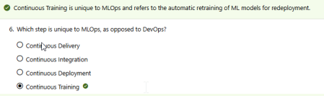
6. MLOps vs. DevOps Execution
- Correct Answer: Continuous Training
- Explanation: Standard software engineering handles Continuous Integration (CI) and Continuous Delivery/Deployment (CD) for regular text-based source code. MLOps introduces Continuous Training (CT) because models degrade as production data drifts, requiring an automated mechanism to retrain the algorithm on fresh incoming patterns.
- Incorrect Options: Continuous Integration, Deployment, and Delivery are foundational structures shared across both classic DevOps environments and machine learning pipelines.
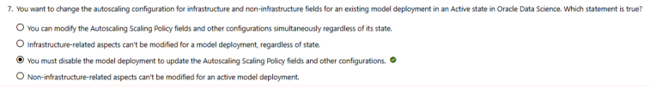
7. Autoscaling Configuration Modification
- Core Rule Context: According to the documentation banner, changes to the Autoscaling Scaling Policy fields must occur independently without changing other fields at the same time if a deployment is currently in an Active state. Non-infrastructure-related updates (like editing the display name, tags, or descriptions) can be done live.
- Explanation: To modify infrastructure and non-infrastructure configurations simultaneously, the model deployment must be modified according to its lifecycle constraints. If active, changes must be decoupled and submitted as separate independent events.
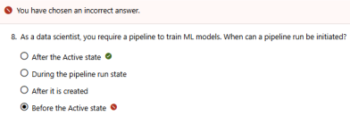
8. Pipeline Run Initiation
- Correct Answer: After the Active state
Why this option is correct:
- Lifecycle state requirement: In OCI Data Science, a pipeline artifact must finish its initialization, provisioning, and validation phases first. Only when the parent pipeline object transitions successfully into the Active state can you actually trigger, schedule, or initiate an individual pipeline run.

Why the other options are incorrect:
- Before the Active state / After it is created: While a pipeline resource exists immediately after creation, its status is typically set to Creating or Updating. You cannot execute a run while the infrastructure configurations and step definitions are still being built or validated by the system.
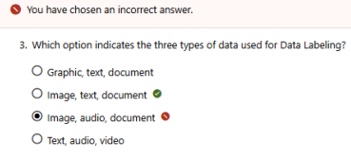
- During the pipeline run state: The Pipeline Run state refers to the execution instance itself that is already actively running your workflow steps. You cannot initiate a brand new run from an object that is currently in an active execution state.
Why this option is correct:
- Supported formats: The OCI Data Labeling service natively manages three core dataset formats: Images (such as .jpeg or .png for classification and object detection), Text (such as .txt files for named entity extraction), and Documents (such as .pdf files used to train document classification models).

Why the other options are incorrect:
- Audio and Video: While audio and video format variations are commonly processed in broader machine learning workflows, the native OCI Data Labeling platform does not currently support direct streaming annotation for them.
- Graphic: This is a generic visual descriptor; the technical OCI classification strictly designates and registers these file assets under the specialized Images resource type.
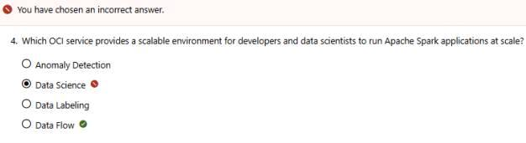
Why this option is correct:
- Managed Apache Spark: OCI Data Flow is a fully managed, serverless big data service that lets you run Apache Spark applications at massive scale without needing to deploy, configure, or manage any cluster infrastructure or underlying servers yourself.

Why the other options are incorrect:
- Data Science (Your selection): While OCI Data Science lets you develop machine learning workflows and can connect to external Spark clusters, it is primarily a platform for managed Jupyter notebooks, model training, and model deployment rather than being OCI's dedicated serverless Spark execution engine.
- Anomaly Detection: This is an AI service with pre-trained models designed specifically for identifying outliers and anomalies in time-series data.
- Data Labeling: This service is used to create and manage labeled datasets (images, text, and documents) for training AI and machine learning models.

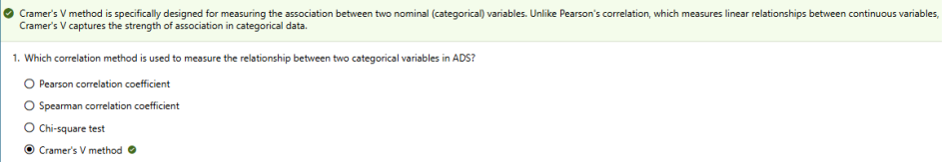
Why this option is correct:
- Categorical variables: In the OCI Accelerated Data Science (ADS) SDK, Cramer's V method is specifically designed to calculate the strength of association between two nominal or categorical variables. It outputs a score between 0 and 1, where 1 indicates a perfect relationship.

Why the other options are incorrect:
- Pearson correlation coefficient: This method evaluates the linear relationship between two continuous (numerical) variables, not nominal data.
- Spearman correlation coefficient: This measures the monotonic relationship between ranked or ordinal variables, making it unsuited for nominal categories with no inherent ordering.
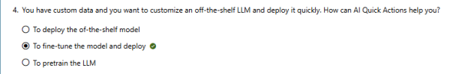
- Chi-square test: While closely related (Cramer's V is calculated from the Chi-square statistic), the Chi-square test itself determines whether a statistically significant relationship exists, rather than directly outputting a standardized correlation value in the ADS SDK feature correlation tool.

Why this option is correct:
- Custom data adaptation: The OCI Data Science AI Quick Actions feature provides a code-free, streamlined environment designed to expand foundational model capabilities. It enables users to take a pre-cached or uploaded open-source LLM, apply their custom training dataset to fine-tune its weights, and then immediately deploy that customized version to a dedicated model deployment endpoint in a few clicks.

Why the other options are incorrect:
- To deploy the off-the-shelf model: While AI Quick Actions can deploy raw, unmodified base models, this choice fails to address your explicit requirement to customize the Large Language Model with your own private data.
- To pretrain the LLM: Pretraining involves training an LLM completely from scratch on massive, raw text corporas requiring months of high-performance cluster computing. AI Quick Actions optimizes existing models through efficient fine-tuning rather than full pretraining workflows.

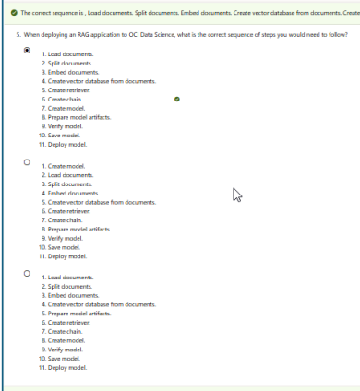
Why this sequence is correct:
Building and deploying a Retrieval-Augmented Generation (RAG) application follows a strict dependency order split into three main phases:
- Data Ingestion & Indexing (Steps 1–4): You must bring in raw textual assets (Load documents), break them into small chunks to fit context windows (Split documents), transform text chunks into numerical vectors (Embed documents), and store those vectors in a searchable index (Create vector database).
- Application Orchestration (Steps 5–7): You construct the query retrieval interface (Create retriever), bind the retriever and prompt templates to a Large Language Model (Create chain), and wrap that entire logic flow into a coherent unified object (Create model).
- MLOps & Hosting (Steps 8–11): Finally, you package your execution scripts like score.py (Prepare model artifacts), test your workflow locally within your notebook environment (Verify model), upload the zipped asset bundle to your registry (Save model), and launch an active compute instance to serve live application endpoints (Deploy model).

Why the other options are incorrect:
- Option 2: This option attempts to execute Create model as the very first step. You cannot initialize or define a model object before you have even ingested data, built your vector search index, or created your orchestration chain.
- Option 3: This option places Prepare model artifacts prematurely at step 5. You cannot package code artifacts before defining the retriever, chain, or model structures that make up the actual payload files.
1. Create Retriever
A retriever is an interface that links your application to your vector database. Its sole purpose is to fetch context based on a user's query.
- How it works: When a user asks a question, the retriever converts that question into a vector embedding. It then scans the vector database (created in step 4) to find the most mathematically similar text chunks [1]—usually using algorithms like Cosine Similarity or Euclidean Distance.
- The output: It returns a set of raw, relevant document snippets (context) that contain the answers to the user's query. It does not generate text; it only searches and retrieves.
2. Create Chain
A chain (often built using frameworks like LangChain) is the orchestrator that glues the retriever, the prompt template, and the Large Language Model (LLM) together.
- How it works: It takes the user's original question and the background snippets found by the retriever, and combines them into a structured prompt template (e.g., "Answer the question based only on this context: [Snippets]").
- The output: It feeds this complete package into the LLM. The LLM reads the context and generates a natural language response. The chain manages this entire end-to-end data flow seamlessly.
1. Functional Dependency (The Model Needs a Logic Definition)
In OCI Data Science, "creating a model" is not just about training an algorithm; it is about initializing a formal OCI tracking object that encapsulates your entire machine learning or AI workflow. If you try to create the model object first, it will be an empty shell. You must first construct the retriever (the data search tool) and the chain (the workflow orchestrator) because they are the exact components that compose the model's intelligence.
2. Packaging for the Artifacts
During the subsequent Prepare model artifacts step, OCI packages your execution files (like score.py) and serializes your components to disk. The serialization process saves the configured chain and retriever pipelines. You cannot serialize, verify, or save a model artifact if its core structural dependencies do not exist yet.
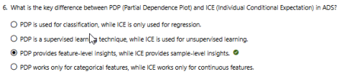

Why this option is correct:
- Global vs. Local Aggregation: In the OCI Accelerated Data Science (ADS) model explainability suite, a Partial Dependence Plot (PDP) shows the average marginal effect of a feature on the target across the entire dataset (global, feature-level insight).
- Individual variation: Conversely, an Individual Conditional Expectation (ICE) plot visualizes the functional relationship between the feature and the prediction separately for each specific row or instance (local, sample-level insight). In fact, a PDP line is mathematically just the average of all the individual lines in an ICE plot.

Why the other options are incorrect:
- Option 1: Both PDP and ICE are completely model-agnostic tools that can be applied to both classification and regression tasks.
- Option 2: Both methods belong strictly to supervised learning interpretability tools used to explain predictive models trained on labeled targets.
- Option 4: Both plots handle continuous numerical data seamlessly. They are not restricted separately by continuous vs. categorical feature rules.
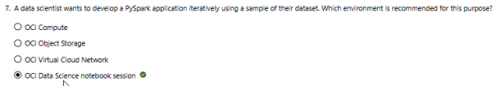
Why this option is correct:
- Iterative interactive development: An OCI Data Science notebook session provides a fully managed JupyterLab environment. It is purpose-built for data scientists to write code, experiment with small samples of data, visualize outputs, and debug code iteratively in real time before scaling up to large batch clusters.

Why the other options are incorrect:
- OCI Compute: This provides raw virtual machines or bare metal servers. While you could manually install Spark, it lacks the managed, pre-configured interactive notebook environments out of the box.
- OCI Object Storage: This is a storage service used to hold raw data files, datasets, and model outputs. It has no computing capacity to execute scripts or application logic.
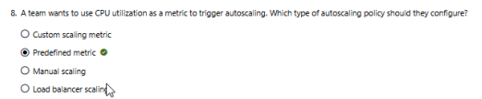
- OCI Virtual Cloud Network (VCN): This is a networking component used to manage secure communications and private subnets between cloud resources, not an execution environment for code.

Why this option is correct:
- Out-of-the-box infrastructure metrics: In Oracle Cloud Infrastructure (OCI) Data Science model deployment, an autoscaling policy based on common infrastructure performance indicators—such as CPU utilization or memory usage—is classified as a predefined metric. The system tracks these metrics natively, allowing teams to set threshold limits (e.g., scale up if CPU usage exceeds 70%) without writing any extra monitoring code.

Why the other options are incorrect:
- Custom scaling metric: This type of policy is reserved for domain-specific metrics or application-level telemetry (such as tracking custom inference error rates or prediction counts) sent manually via the OCI Monitoring API.
- Manual scaling: This requires a user to explicitly adjust the instance count or shape via the console, CLI, or API, rather than triggering automatic scaling in response to fluctuating workloads.
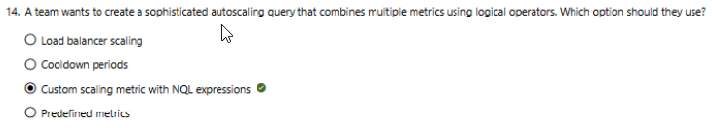
- Load balancer scaling: This is a distraction; while a load balancer routes traffic among active model deployment instances, the autoscaling policies themselves are applied directly onto the compute instances utilizing either predefined or custom criteria.

Why this option is correct:
- Advanced and complex querying: The OCI Monitoring service uses Monitoring Query Language (MQL) to express and evaluate metric data.
- Combining multiple metrics: MQL allows you to construct sophisticated queries using logical and mathematical operators (like AND, OR, +, or /). This means you can design a rule that triggers autoscaling only when a unique combination of conditions is met simultaneously (e.g., when CPU utilization and network traffic throughput both cross specific thresholds).

Why the other options are incorrect:
- Load balancer scaling: Load balancers distribute incoming application traffic, but they do not provide a multi-metric query language interface to define the compute instance pool's scale-out rules.
- Cooldown periods: A cooldown period is an operational configuration parameter that specifies the amount of time to wait between consecutive scaling actions to let the system stabilize. It is not a metric querying tool.
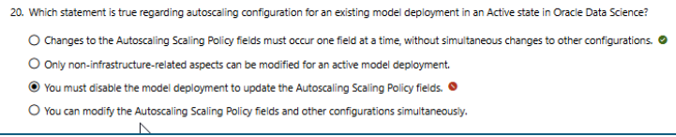
- Predefined metrics: Predefined metrics provide basic, single-metric auto-scaling triggers (like a standalone CPU threshold) out-of-the-box. They do not support custom multi-metric logical combination queries.

Why this option is correct:
- Decoupled execution constraints: When an OCI Data Science model deployment is in an Active state, the platform imposes structural restrictions on updating live infrastructure. Changes to the core autoscaling engine configuration fields must be executed and submitted individually as singular, isolated updates. They cannot be combined with non-autoscaling configuration fields (like updates to instance counts or description metadata) in the same API transaction.

Why the other options are incorrect:
- Third option (Your selection): This is incorrect because you do not need to disable or delete the active deployment. Modifying autoscaling dynamically on a running, live production endpoint is fully supported by OCI without forcing application downtime.
- Second option: Both infrastructure-related configurations (such as autoscaling parameters) and non-infrastructure items (such as descriptions or logging categories) can be modified while active, provided they are sent as separate update requests.
- Fourth option: This directly contradicts OCI rules because submitting simultaneous mixed modifications while in an active state is explicitly blocked by the resource validation engine.
Model Taxonomy
Model taxonomy deals with the organization, classification, and structure of machine learning models within a system. It provides a shared vocabulary for how different models relate to one another.
- Core Purpose: To categorize models based on their architecture, capabilities, intended use cases, or performance domains.
- Focus: "What is this model?" (e.g., classifying a model as an LLM, a CNN, or a Regression model).
- Key Use Case: Helps enterprise teams quickly find the right model for a specific task without recreating it, and ensures consistency across different business units.
Model Provenance
Model provenance deals with the lineage, history, and traceability of a model. It tracks the entire lifecycle of a model from its creation to its deployment.
- Core Purpose: To provide an audit trail detailing exactly how, when, and by whom a model was trained.
- Focus: "Where did this come from?" (e.g., tracking the exact training data, hyperparameters, source code, and training environment used).
- Key Use Case: Crucial for model reproducibility, debugging, intellectual property protection, and regulatory compliance.

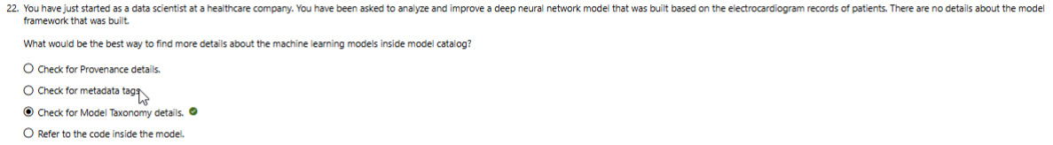
Why Model Taxonomy is correct instead of Provenance:
- Model Taxonomy: In OCI Data Science, the taxonomy metadata specifically documents the model framework and architectural characteristics. It explicitly records key attributes like the machine learning framework name (e.g., TensorFlow, PyTorch), framework version, and the mathematical task type (e.g., binary classification). Since your primary missing detail is the model framework, this is the exact field designed to provide that structured information.
Why not Provenance?
- Model Provenance: Provenance tracks the reproducibility pipeline and lineage history of the model rather than its structural identity. It contains information such as the specific Git repository URL, the exact commit hash, the training script filename, and the OCI resource (like a Notebook session OCID) where the training occurred. While it helps you trace where the model came from, it does not directly classify or flag the underlying framework type in the catalog metadata view like taxonomy does.
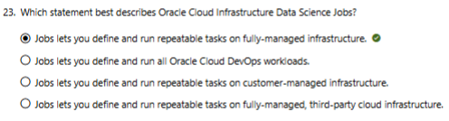

Why this option is correct:
- Fully-managed batch tasks: OCI Data Science Jobs are built specifically to execute standalone, repeatable workloads (like model training, data preprocessing, or batch inference). The infrastructure is completely fully-managed, meaning Oracle automatically provisions the compute resources when the job starts and tears them down immediately after completion.

Why the other options are incorrect:
- Option 2: Data Science Jobs are intended specifically for machine learning and data workloads, not generic software CI/CD pipelines or all Oracle Cloud DevOps workloads (which are handled by the OCI DevOps service).
- Option 3: The infrastructure is managed natively by Oracle, not customer-managed. You do not need to configure or maintain the underlying servers yourself.
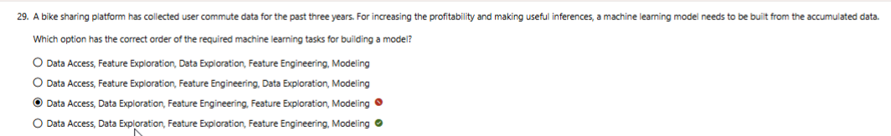
- Option 4: It runs natively inside Oracle Cloud Infrastructure, not on third-party cloud infrastructure like AWS or Azure.

Why this sequence is correct:
This order follows the logical flow of the OCI Accelerated Data Science (ADS) workflow lifecycle:
- Data Access: First, you connect to your data source (e.g., OCI Object Storage or an Oracle Database) and load the raw dataset.
- Data Exploration: Next, you look at the dataset as a whole to check its overall structure, shape, data types, and any missing value patterns.
- Feature Exploration: Once you understand the overall dataset, you zoom into individual columns (features) to look at their distributions, identify correlations (like Cramer's V or Pearson), and look for class imbalances.
- Feature Engineering: Armed with the insights from your exploration, you can now safely transform the columns (e.g., scaling numerical features, encoding categories, handling missing values).
- Modeling: Finally, your clean, engineered dataset is fed into machine learning algorithms for training.

Why your selection was incorrect:
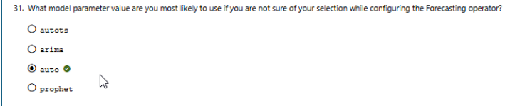
Your choice put Feature Engineering before Feature Exploration. You cannot properly transform or engineer features before you have thoroughly explored them to understand their relationships and behaviors. Exploration must always guide the engineering phase.

Why auto is correct:
- Automated Model Selection: In the OCI Data Science Forecasting operator, setting the model parameter to auto flags the service to evaluate your historical time-series data characteristics automatically.
- Smart Routing: It triggers the "Auto Select Per Series" capability, which matches each data group to the specific statistical framework (like arima or prophet) that delivers the best predictive fit, removing the need to benchmark every model manually.

Why the other options are incorrect:
- arima: This forces the system to strictly use the Autoregressive Integrated Moving Average framework, which might underperform if your data has highly non-linear or holiday-based patterns.
- prophet: This explicitly locks the execution pipeline into Facebook's Prophet framework, ignoring traditional statistical patterns better handled by standard models.
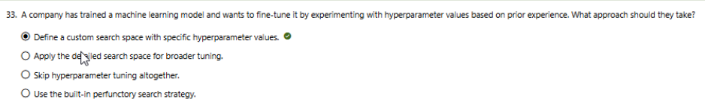
- autots: This is an invalid configuration parameter name for model selection within this specific OCI low-code operator schema.

Why this option is correct:
- Leveraging domain knowledge: When you already have "prior experience" regarding which hyperparameter ranges perform best for your model, defining a custom search space is the optimal strategy. It allows you to bound the exploration strictly to targeted ranges, saving significant compute time and cost by not evaluating irrelevant values.

Why the other options are incorrect:
- Apply the detailed search space for broader tuning: A broad or default detailed search space scans a wide range of values completely unguided by your prior experience, which leads to highly inefficient training runs.
- Skip hyperparameter tuning altogether: This fails to fulfill the company's objective, as their goal is explicitly to fine-tune and optimize the model.
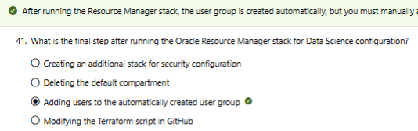
- Use the built-in perfunctory search strategy: A perfunctory (surface-level) strategy only tests a tiny, generic subset of default configurations. It completely ignores your specialized domain experience.

An ORM Stack (Oracle Resource Manager Stack) is a collection of OCI cloud infrastructure resources that are defined, deployed, and managed as a single unit using Infrastructure as Code (IaC).
Key Characteristics:
- Powered by Terraform: Resource Manager uses standard HashiCorp Terraform configurations to declare what resources you want (networks, compute shapes, user groups).
- State Management: The stack stores and locks the Terraform state file securely in the cloud, tracking your infrastructure over its entire lifespan.
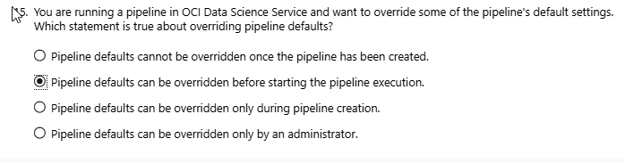
- Automation Templates: Pre-built templates (like the Data Science Service template seen in your earlier questions) allow you to safely deploy complex cloud setups in a few clicks without manual scripting.

